**CONCURSO NACIONAL DE DISCURSOS STANZA 2024**

**LEVEL 1**

**TEMA: MI OBRA DE ARTE O ARQUITECTURA FAVORITA**

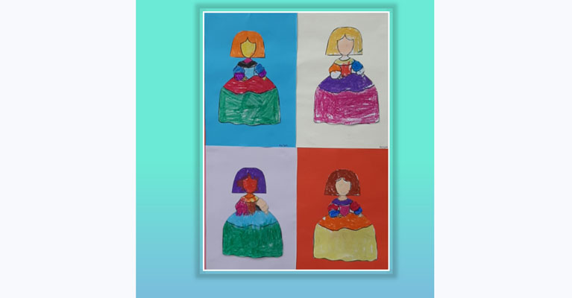

**Rules for Level 1**1. Cue cards are allowed but the speech should not be read. **Presentation is the most important aspect of the speech competition this year. Is it engaging?**

2. Candidates will need to state at the beginning of the recording the following information:  
  Name of the candidate; Name of the School; Level

3. **The recording MUST be clearly labelled with name, school and level**.

4. Candidates may submit an audio or video file. If the file is too large to email, it can be shared through Google Drive.

5. Candidates must also **share an image of the piece of art or architecture** being presented.

5. Candidates should cover **all** the questions listed but can do so in any order. The total oral presentation should be of **a minimum of 1 minute to a maximum of 2 minutes.** The introduction of the student (name, school etc) is not taken into account when timing the speech.

6. Once started, the recording should not be interrupted.

7. The speech should be the candidates’ **original** production.

7. **Native speakers may not enter but can enter the “scholarship” competition.**

**PREGUNTAS**

1. ¿Cómo se llama tu pieza favorita de arquitectura o arte? ¿Dónde se encuentra?
2. Descríbela.
3. ¿Por qué te gusta esta pieza?
4. ¿Qué aspectos de la obra te parecen más interesantes?
5. En tu opinión, ¿por qué es famosa?

**There should be no more than three entries per level per school.**

**DUE BY MONDAY 2nd SEPTEMBER TO:**

[cherylv@stcuthberts.school.nz](mailto:cherylv@stcuthberts.school.nz)